**Hamna Qasim 55194**

**Web App Development Lab # 5**

**Tasks**

**Task1: Check the type of bigint and symbol.**





**Task2: Create a const object called “Product” to store information shown in the given picture.**

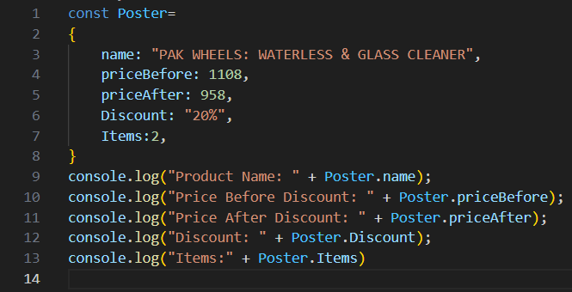

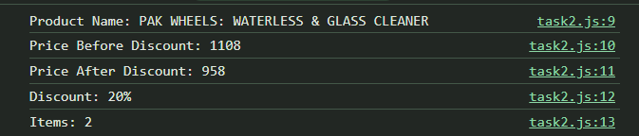

**Task3: Create an object to create your Instagram profile. With screenshot of profile**

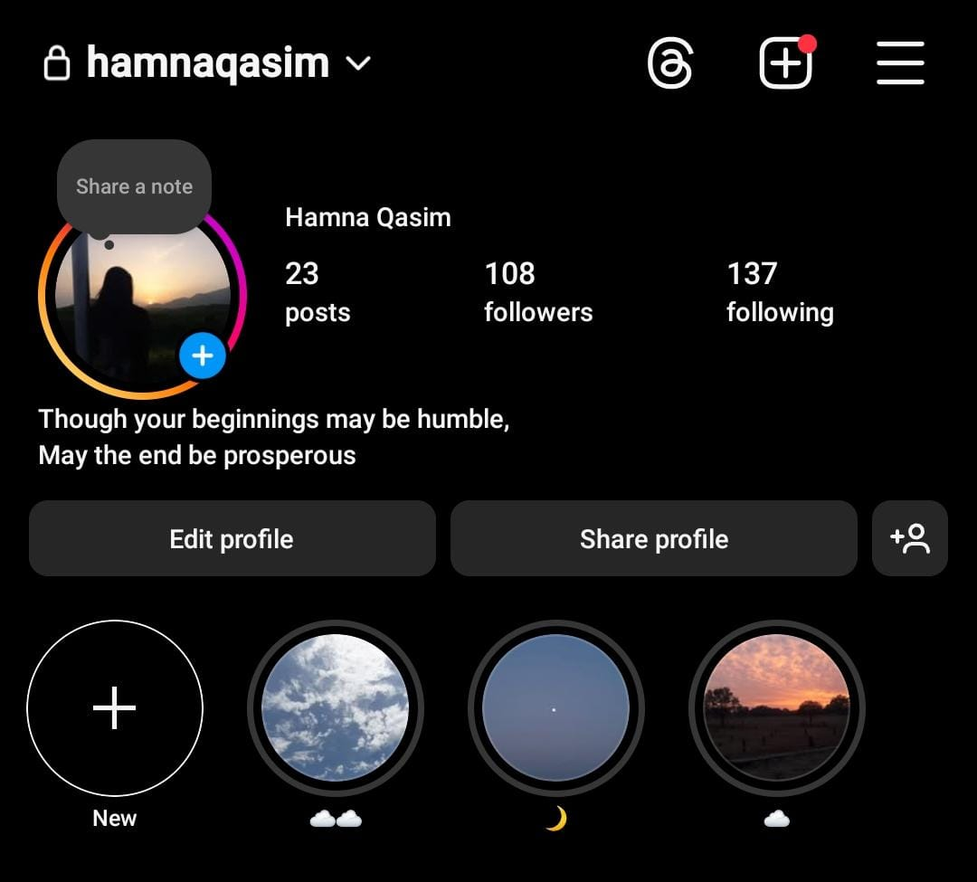

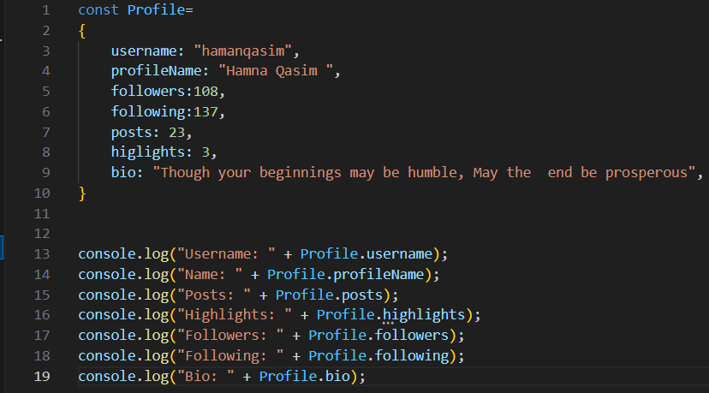

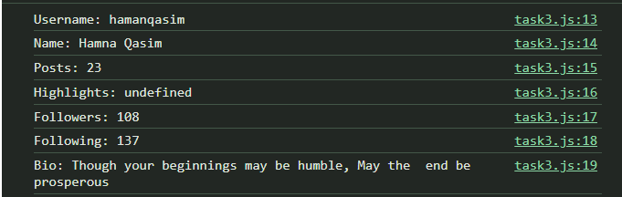

**Task4: Apply unary operators. ( a++ , ++a , a--, --a)**

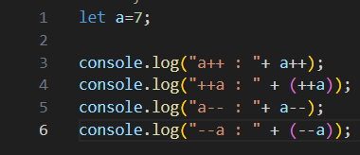

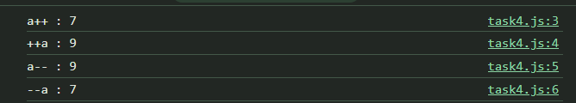

**Task5: Get user to enter a numbers and check it its multiple of 3 or not?**

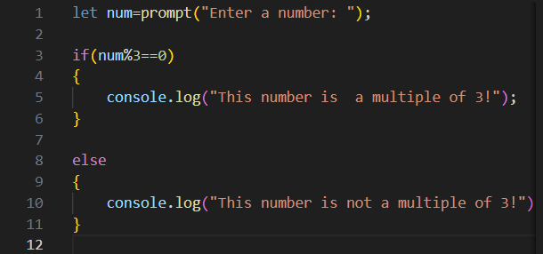

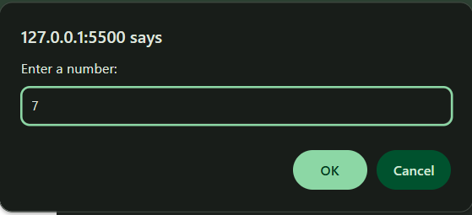



**Task6: Write a code which can give grades to students according to their scores.**



